Odyssey Prerelease: Quick Strategy Guide
Alex Shvartsman
In working on this article I faced a challenge unique to this type of tournament. On one hand, my job here is to try and help my readers perform better this weekend. On another, the most important thing about the Prerelease is the joy of discovery - most of you would much rather figure out how to best utilize the new cards rather than have me offer my opinion. Thus, here is some general advice that will help you make sense of Odyssey. I leave the rest up to you. Have fun this weekend!

Threshold
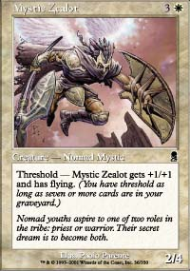
Many of the cards in the set offer threshold abilities that are extremely attractive. However, you should be careful not to overload on cards that are mediocre until threshold has been met. Getting seven cards in the graveyard does not sound like a difficult thing to achieve, but it is actually harder than it looks. Many Limited games will end well before there are seven cards in either player's graveyard. There are also numerous creatures that remove cards from your own, or your opponent's graveyard to activate their abilities. Mystic Zealot is a perfect example of a good Limited card with threshold. On its own, it is an unspectacular, but perfectly playable creature that you won't mind having out on turn 4. Later in the game it becomes a potentially game-breaking card - but you are never stuck with dead weight no matter when you draw it.
Speaking of the graveyard manipulation. In this set, graveyard is a resource. There are a number of cards that get better or worse, depending on how many cards are currently in yours, or your opponents, graveyards. There are also a number of effects that will let you discard cards from your hand, thus filling up the graveyard more quickly. Consider these cards carefully when building your deck and ascertaining the quality of your threshold cards.

Flashback
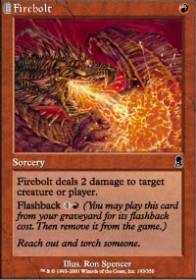
Many of the common flashback cards are very good. Although most flashback costs are relatively high, these cards provide you with more mid- to late-game tools. Firebolt is excellent at one mana, despite being a sorcery (think back to how many times you've drafted Assault/Battery just for the Assault part) and you will not mind paying through the nose to cast it again later in the game. Pretty much anything with a flashback of six or less should be considered strongly, provided the card's ability is powerful enough to play in the first place. There are a number of cards with high flashback costs (8+). Although this format looks to be relatively slow in Limited (I may well be proven wrong, but that is the initial impression), you are not casting 8 casting cost spells often enough to consider those cards for their flashback ability. Kavu Aggressor is a perfect example here - although you will pay its kicker every once in a while, you don't plan on it when drafting or building your deck.

The Kindle Mechanic
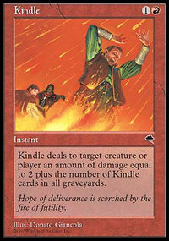
There are several cards in the set that utilize the same mechanic previously seen on Kindle and Accumulated Knowledge. When building a sealed deck, this won't often become a consideration. Rather, you will decide whether to play these cards based on how much an individual copy of it can do for you. In an all-Odyssey draft however, some of these cards become very, very attractive. Think back to Tempest (Kindle and Muscle Sliver). You will have a good chance to draft three or more copies of these cards if you set out to do so. You will also find surprise ways to make the 'Kindle' cards even better - but I don't want to give away too much.

The Mana
Invasion block taught us to play three-color decks standard. It taught us that we can get away with playing horrible mana to splash color number five for that Volver. When entering an Odyssey Prerelease, throw that knowledge out of the window.
Invasion was specifically designed to be a multicolor set. Commons never required more than one mana of a specific color to be cast, there are many excellent common cantrips (Exclude, Zap, Hobble) and the block was rich with mana fixers. Odyssey was not meant to be a five-color set. Cards that require two or even three mana of a specific color to be cast are back. There are some cantrips, but not as many as in Invasion. Thus, draft or build your deck to be based on two colors. It will certainly be possible to splash a touch of a third color. As a matter of fact, there is a cycle of common lands that will help you cast an off-color power card more easily. However, drafting three or more colors across the board is no longer a good idea.

Draft and Sealed
Most Prereleases offer both sealed and draft play. In most cases, you will have enough time to play in a sealed deck tournament and then pick up a draft or two. Those of you who have not drafted before (yes, both of you!) should consider this an opportunity to get in on the coolest format in Magic. The set's lead developer was Randy Buehler, a draft aficionado if there ever was one. He was certain to make sure drafting Odyssey will be a fun, balanced format.

